**To Fly App Research Paper**

Kenneth Lasseter; Marjory Stoneman Douglas

Theon Thomas; Pompano Beach High School

Justin Chacko; College Academy at BC Central

Christina Dulal; Miramar High School

Abstract

The first section of our paper is our Background, which discusses the physical “To Fly” exhibit’s parts and why we chose it as the subject of our application. Following the Background are our methods, where we each discuss our role in the application’s creation and the methods used in order to reach our final product. In the Results section, there are detailed explanations of our application’s key features and how they relate to the “To Fly” exhibit in the Museum of Discovery and Science. Following the Results section is the Discussion section, where we reflect on the current state of our application and deliberate the future of the application. Our Acknowledgements section is where we give thanks to the institutions and individuals that aided in the development of our application and gave us the opportunity to work together. In our References, we give credit to the websites and programs that provided the content needed to make the application what it is today.

Background

We chose To Fly as our exhibit during the APP-titude internship at the Museum of Discovery and Science due to our common interest in aircrafts. Whether it was how to pilot a craft, learning the mechanics behind the craft, or learning the physics of flight itself, each member of our group had a fascination with flying. By choosing this exhibit to work with, our group aimed to share that fascination with the Museum’s patrons. When doing research on the exhibit we discovered that the To Fly exhibit was meant to lead Museum guests through the history of flight eventually culminating with landing on Mars. We would not have found this out without being told by the Museum employees themselves so we saw an opportunity to make this point more clear. The To Fly exhibit contained many signs and plaques containing information on the various planes displayed. With this kept in mind, we decided that our app should be supplemental to the To Fly exhibit by providing additional information rather than reiterating what was already aptly displayed.

Methods

During the development of our application for the To Fly exhibit, we assigned roles that best suited our skills. Our Java programmer was Kenneth Lasseter due to his prior knowledge in coding and computer science. User Interface was handled by both Justin Chacko and Christina Dulal due to their combined interest in programming and creativity in terms of design. The graphics for our application were made by Theon Thomas. Prior to beginning our app development at FAU, we had to familiarize ourselves with the Museum of Discovery and Science, especially with the To Fly Exhibit. We spent countless hours roaming the museum and studying our exhibit. We read every placard, used every flight simulator, and did research on every single display. We wanted to fully understand what the exhibit was portraying to museum visitors so that we could create an app that effectively supplemented visitors’ experiences as they explored the museum. The To Fly exhibit encompassed many aspects of powered. Heavier-than-air flight. It taught about the different plane parts and their functions, the different materials that planes are made of, and the way that planes in the air interact with airports and other planes around them. The exhibit also housed many different flight simulators for visitors to play with. While at the Museum, we also studied the previous To Fly app and contemplated different ways to improve its usability and educational structure. While the previous app was effective in explaining each display in the exhibit, it failed to actively provide supplemental material for visitors. We decided that we needed to not only improve the user interface, but also the information that the app covered. We did however like the structure of the home screen of the previous app and decided to keep that the same. When it was finally time to attend the android development class at FAU, we knew precisely what our goal was, we just had no idea how to accomplish it. Kenneth’s experience in Java provided him with a good base for the class, but the countless foreign android methods were still completely new to him. Christina and Justin, who were completely new to computer programming, were tasked with creating a sleek User Interface that connected the app user to the code behind the scenes. But the task given to each individual did not matter; Kenneth, Christina, and Justin all became coherent in both Java and developing user interfaces. Theon worked in unison with the whole team, creating graphics for whichever activity the team may have been developing. While at FAU, we learned to use many different tools for app development. The most important tool used in creating Android code is Android Studio. Android Studio is Android’s official IDE, or integrated development environment. This is what our team used to develop all the code in our app. This tool is important because it allows developers to write code that works effectively by alerting them of logical errors and showing simpler ways of achieving tasks. It has many features including debugging, performance tooling, a flexible build system, and an instant build/deploy system that can instantly install your app on an Android device. The main tool that we used for developing the graphics is Adobe Illustrator. Adobe Illustrator is an imaging and photo editing software that enables developers to create unique and high quality graphics that can be used in the app. We also used Github to create the code for this app collaboratively and to post our code and other material relating to the app development including videos and balsamiq mockups. All of this can be found at our Github repository: <https://github.com/MODS16Apps/To-Fly>.

Results

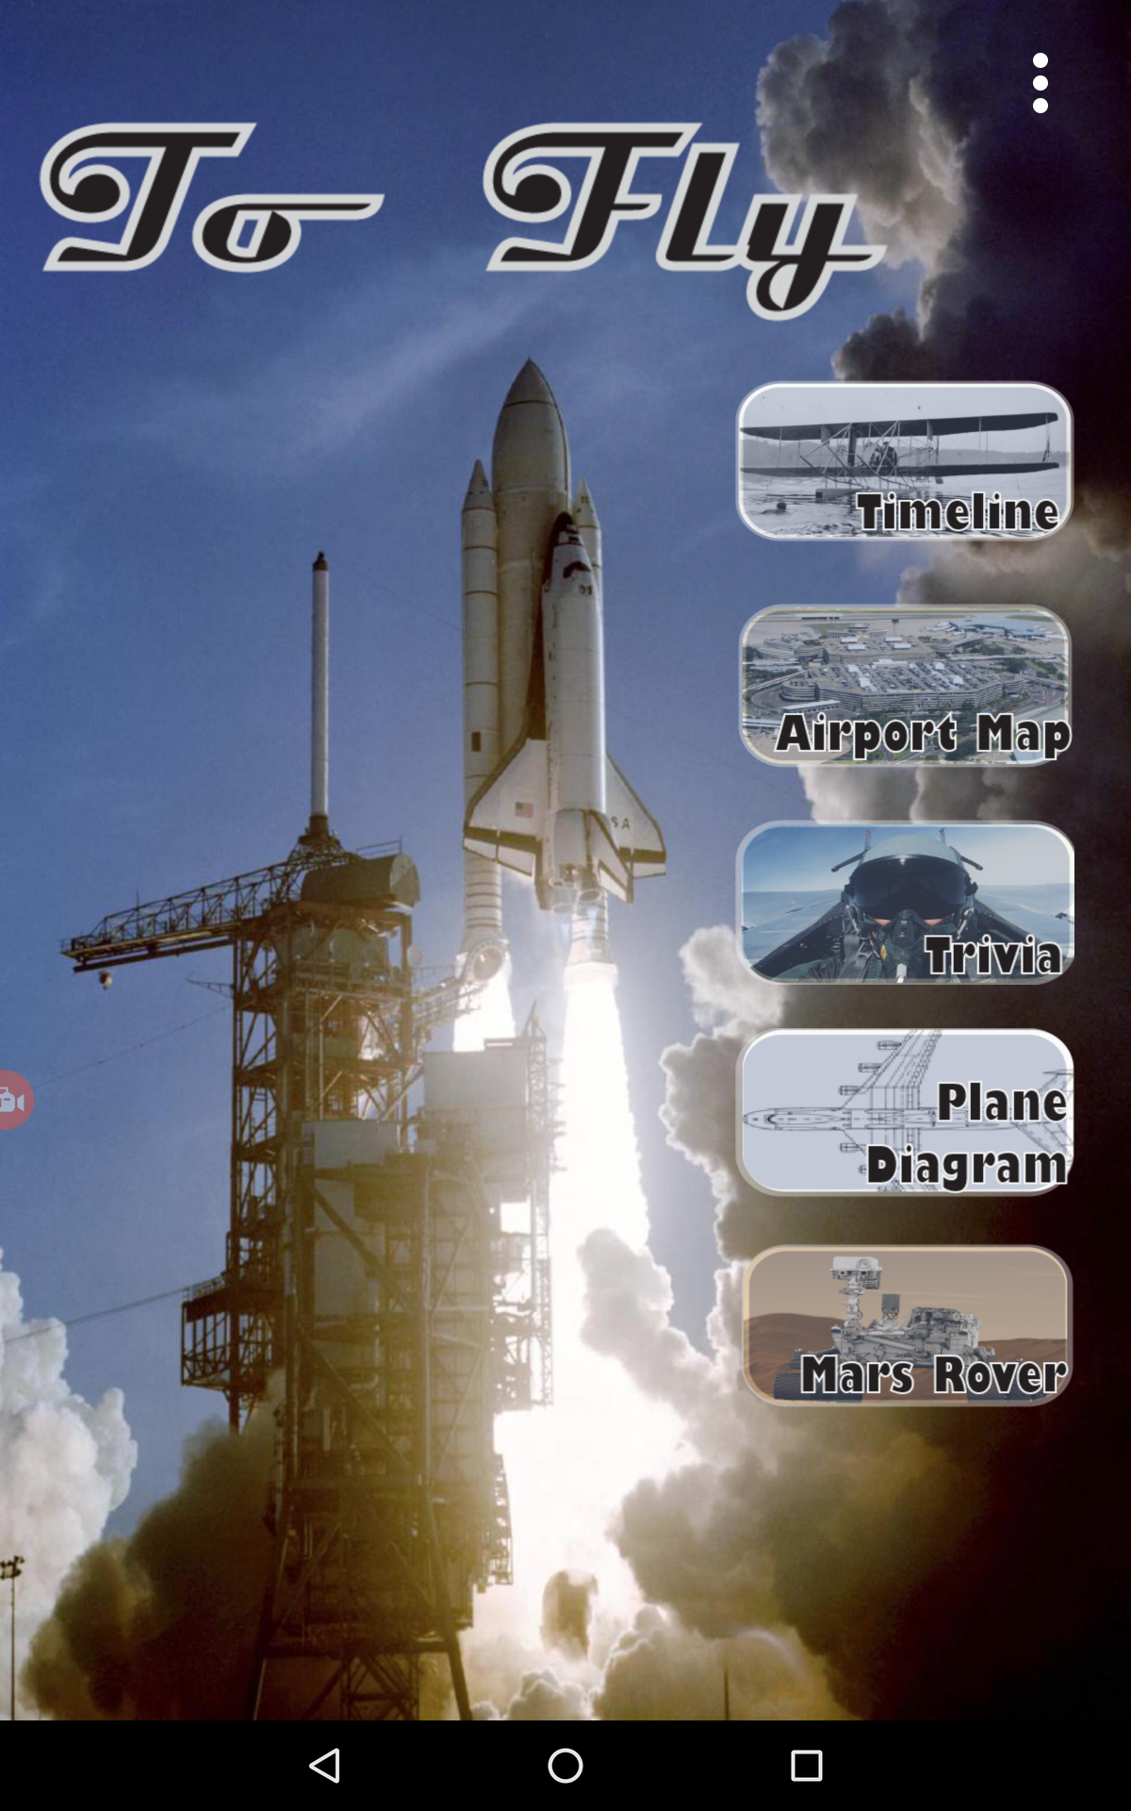

**Main Menu:** This layout is very similar to last year's app. We changed the background to a much clearer picture, so that it will contrast with the buttons more effectively. The font for the name of the app changed to a more modern one and we made the whole main menu a full screen. Now in the main menu, there is no awkward space of an action bar and a status bar; this helps to make the app look more attractive. Lastly, the buttons are changed and have a click effect whenever you press them.

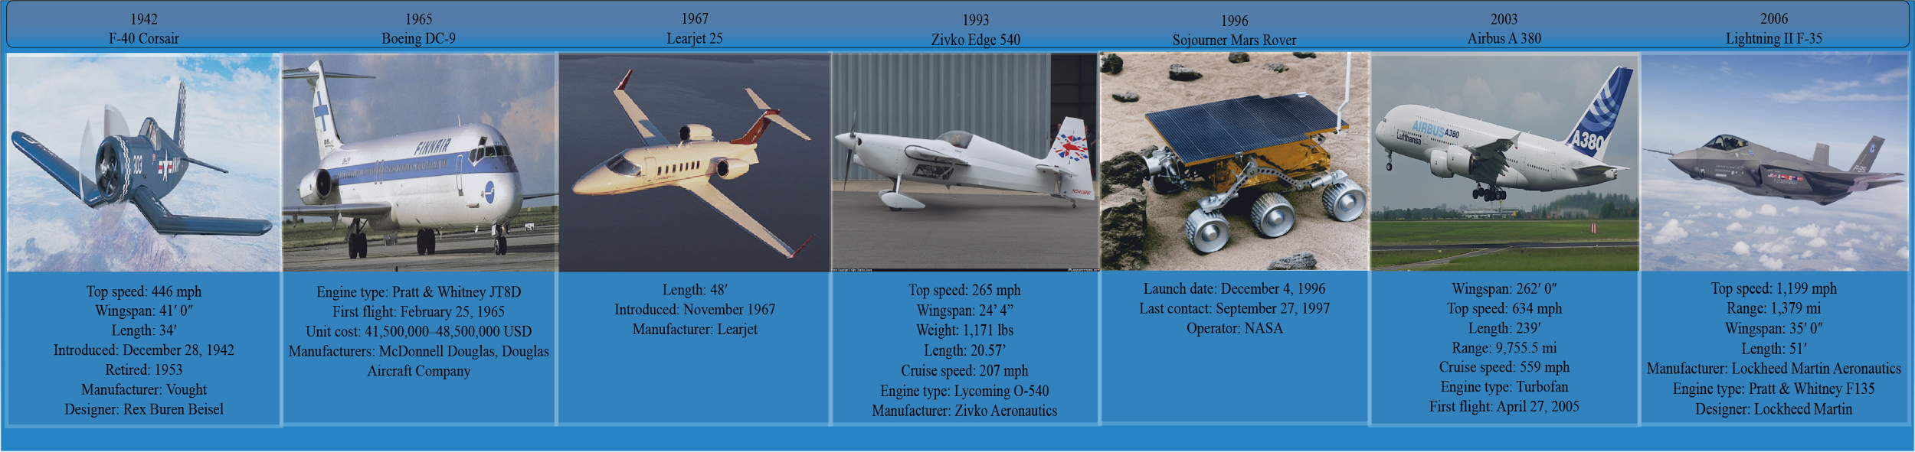

**Timeline:** This is the first button. When you view it on the tablet, you will only see one plane at

a time and you are able to slide left and right through the whole timeline. The timeline was used to condense all the information that was composed for all the planes of last year’s app. Last years app was named simulators, and it was filled with paragraphs for each plane. A timeline gives all the basic information that the user needs and also organizes them in a more effective layout.

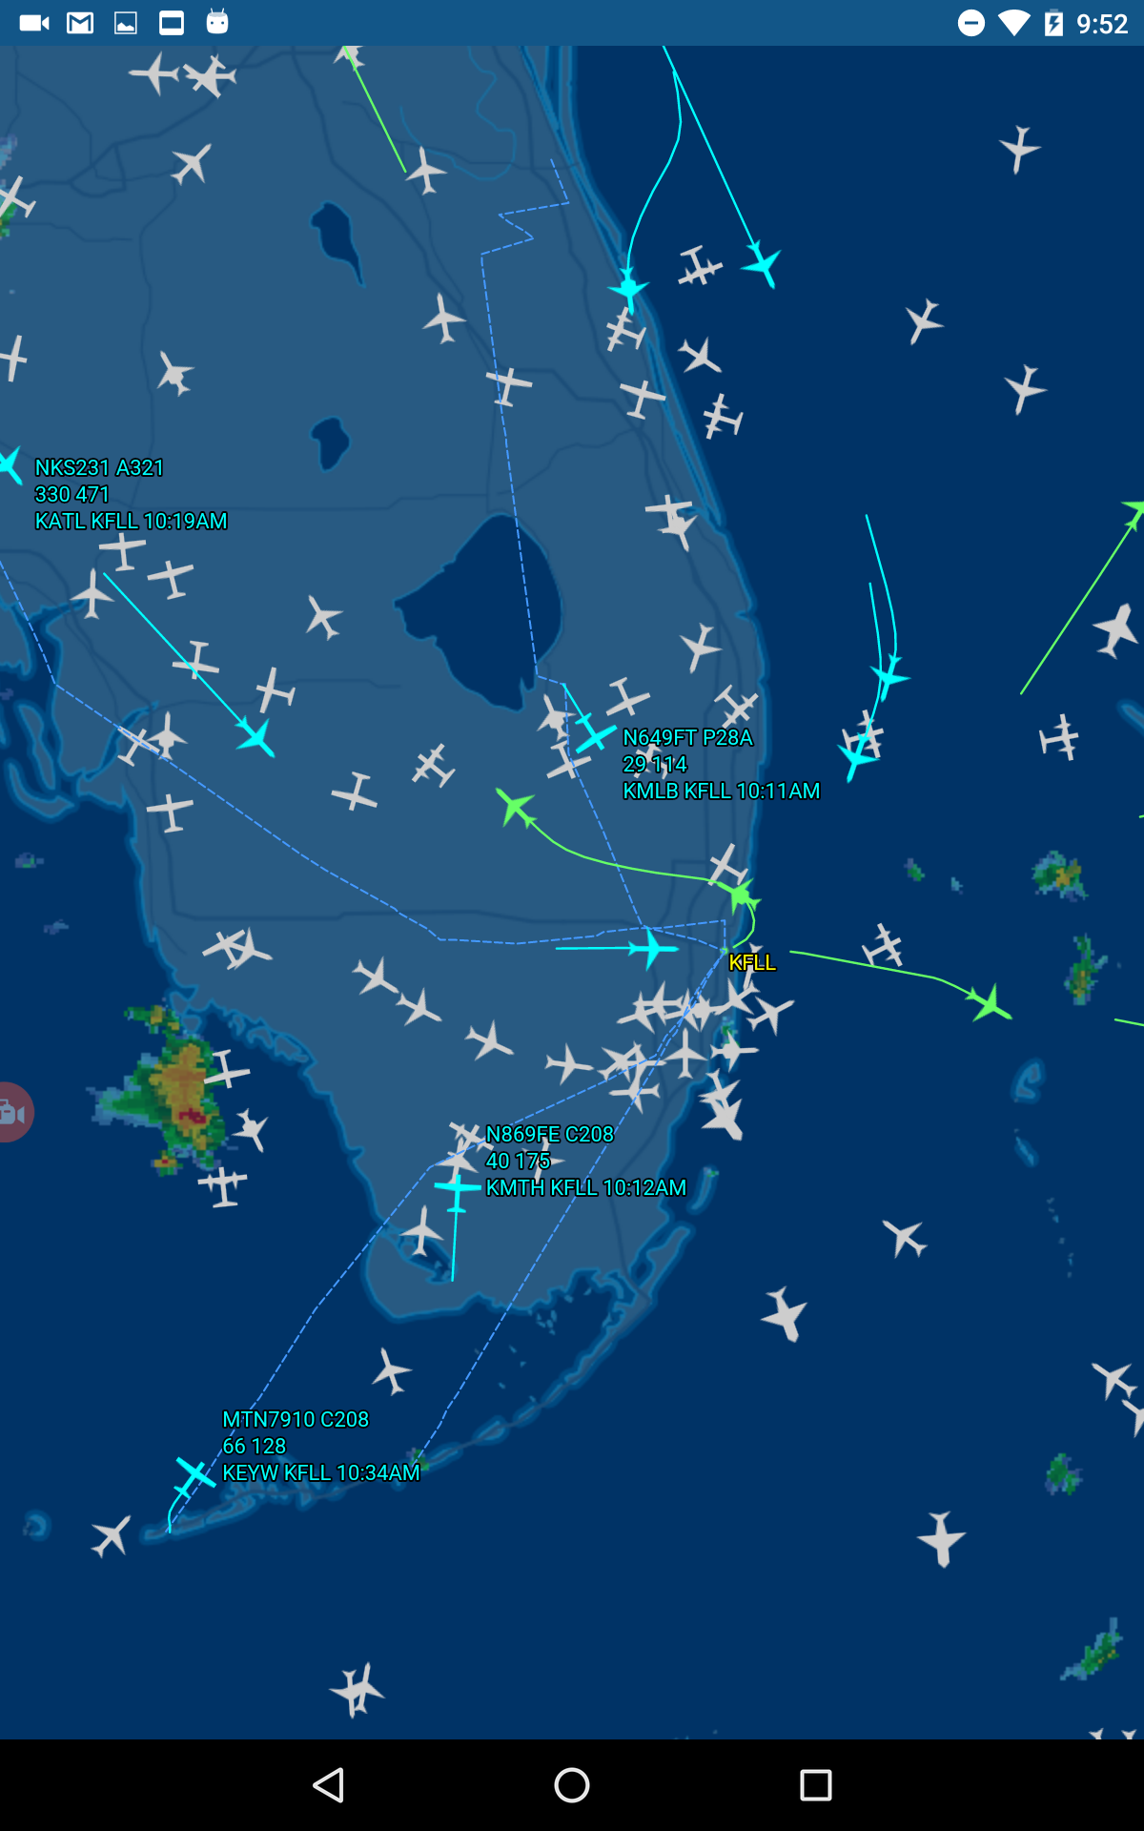

**Plane Tracker:** This can be found under the airport maps button. The plane tracker gives a live feed of the planes that are arriving and departing ft.lauderdale international airport.It even gives background sounds of a control tower to give the impression to the user that they are witnessing an event that is happening in real time. We added this feature because it was missing from the previous app, and it was the best way to incorporate the control tower that is found in the museum to the app. The control tower in the museum is not live and just repeats what happens on average in a control tower. This feature of the app takes the control tower exhibit to a higher and more advanced level.

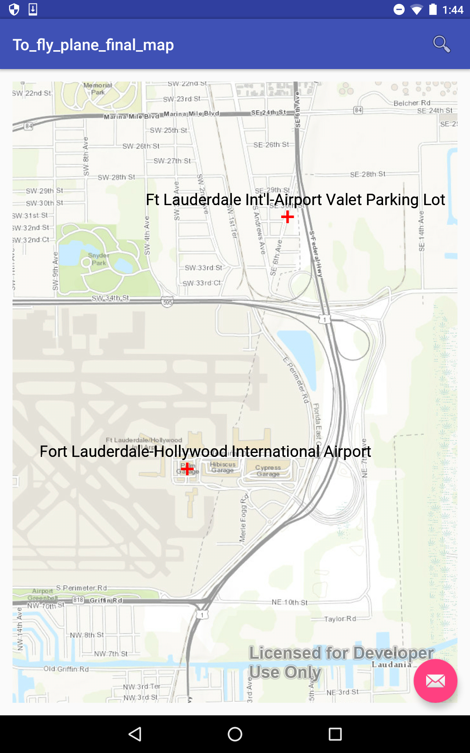

**Esri Map:** This is also contained in the airport maps button. The Esri map is very interesting. We used it so that you can search any airport that you like; you are able to see what is closeby to those airports also. We used esri because it was more customizable than google maps and much more quicker.

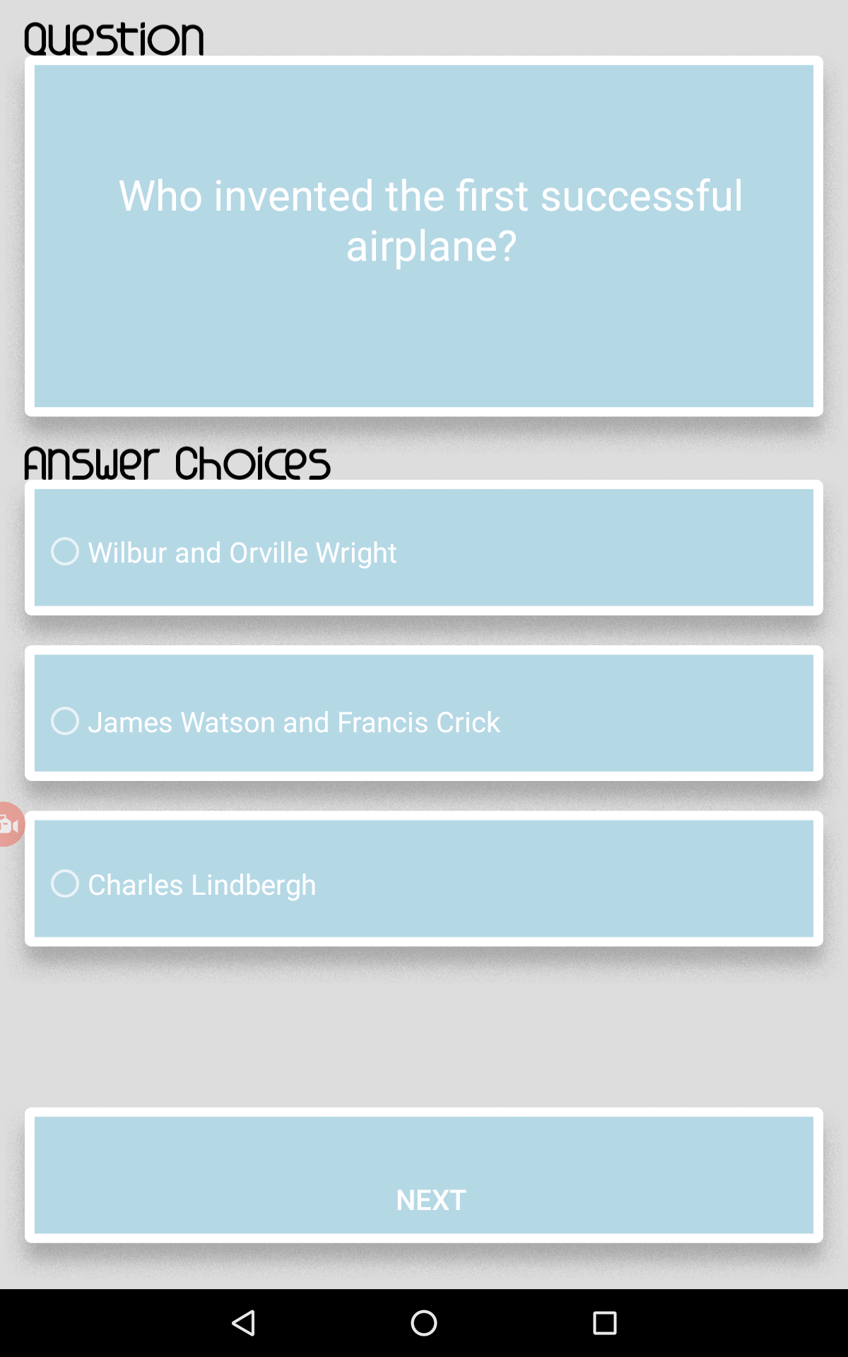

**Trivia:** This is the third button and contains a simple trivia game. Students will have to answer 10 questions and they will get their results and also explanations when they reach the end of the quiz. We liked last year’s trivia game and so we kept the layout the same. We changed a couple of questions so that it will relate to the To Fly Exhibits better.

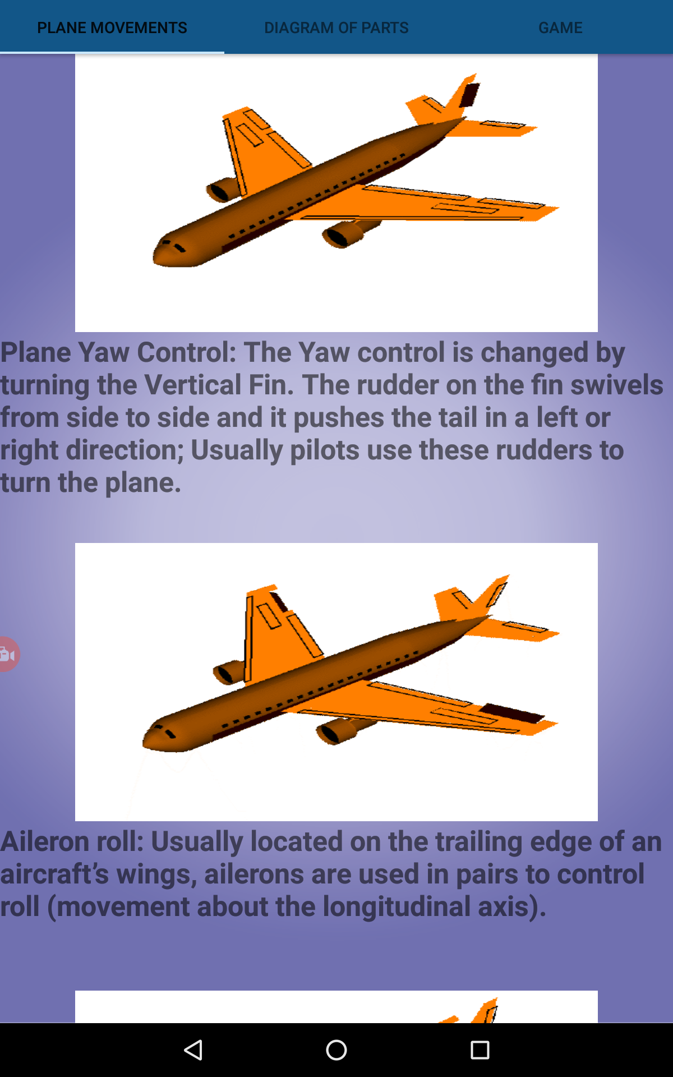

**Plane Movements:** This is the screen you will first see when you click on the plane diagrams button. This was content that was not mentioned in the previous app. When you go to the museum there are two exhibits to show how a plane moves and so we incorporated this into our app because it was important. The three pictures on this screen are a gif and play on a loop.

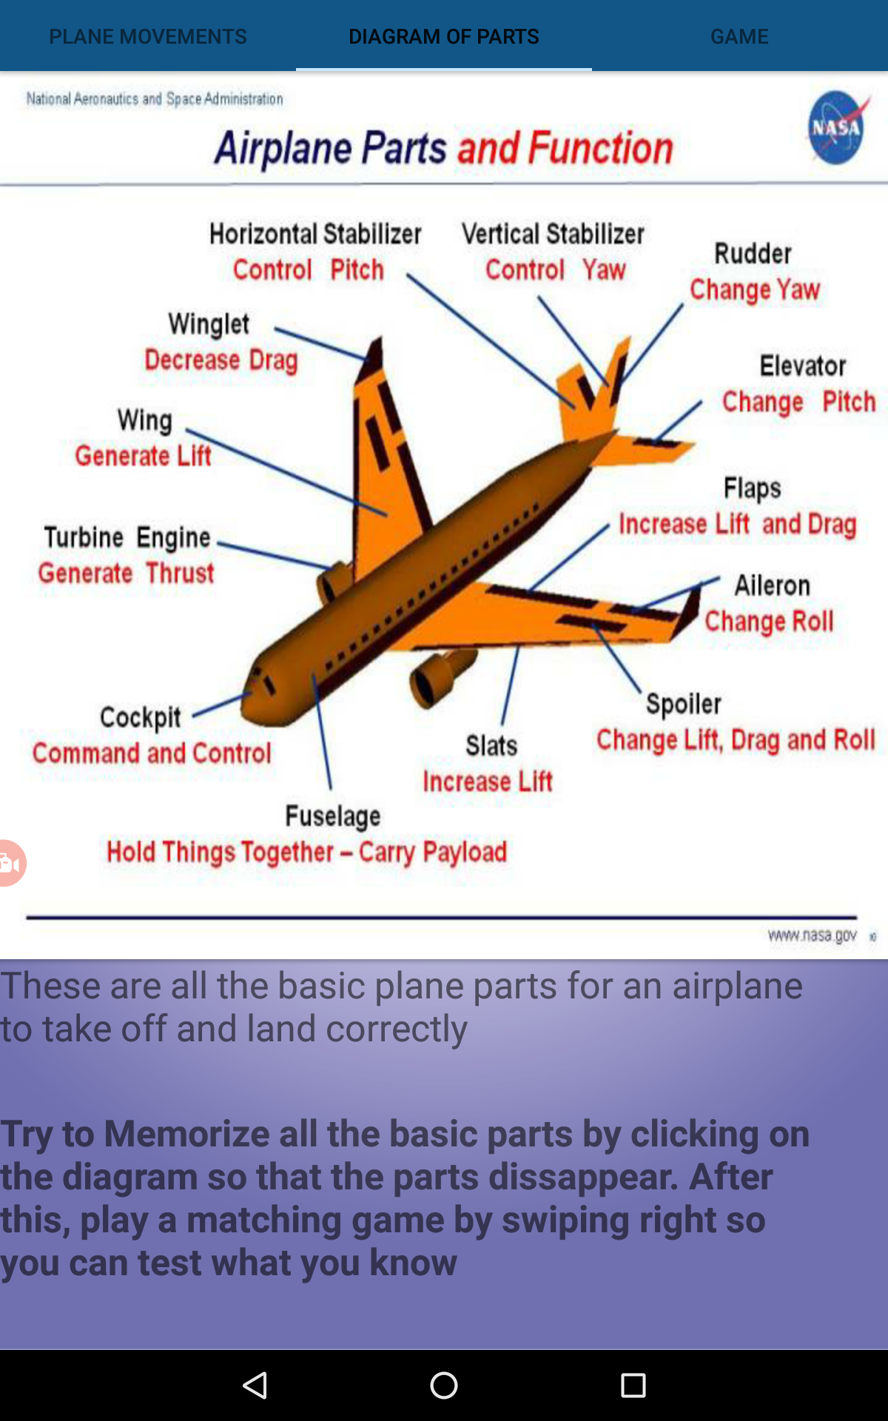

**Diagram of Parts:** In the museum, there is a full wall dedicated to name the 500+ names of all the parts that are involved in a plane. We thought that the average visitor would not spend their time trying to learn the parts and walk away from it because it has a lot of information, but it is still important to the To Fly Exhibit. Incorporating the plane parts to the app helps them to learn all the basic information they need in a more appealing fashion. They are able to click on the picture so that the plane parts disappear as they try to memorize them. Later they are challenged to play a game to match all the parts to see what they know.

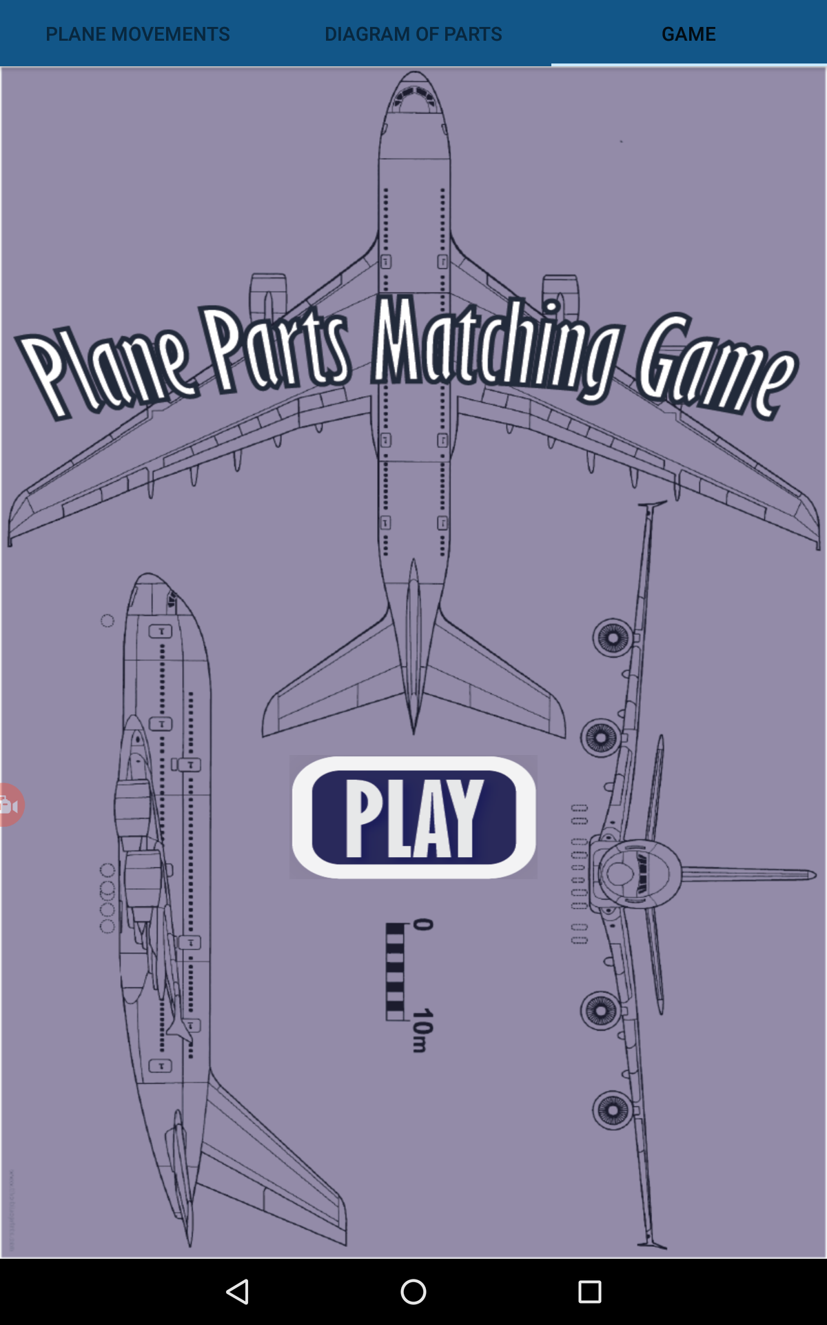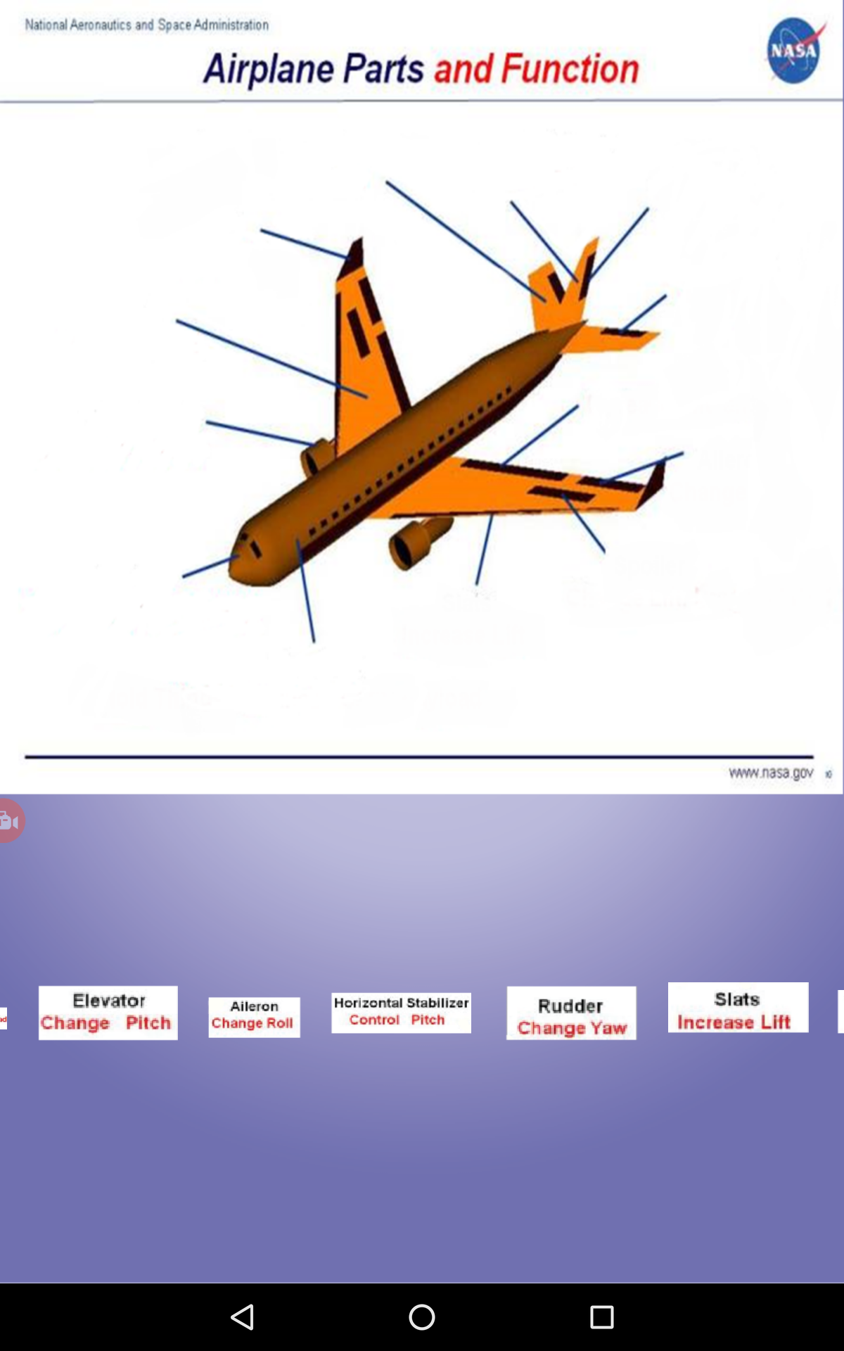

**Plane Parts Game:** This is where students will be tested on what they learned from the diagram. It is a simple game where they drag and drop the correct parts to the empty diagram

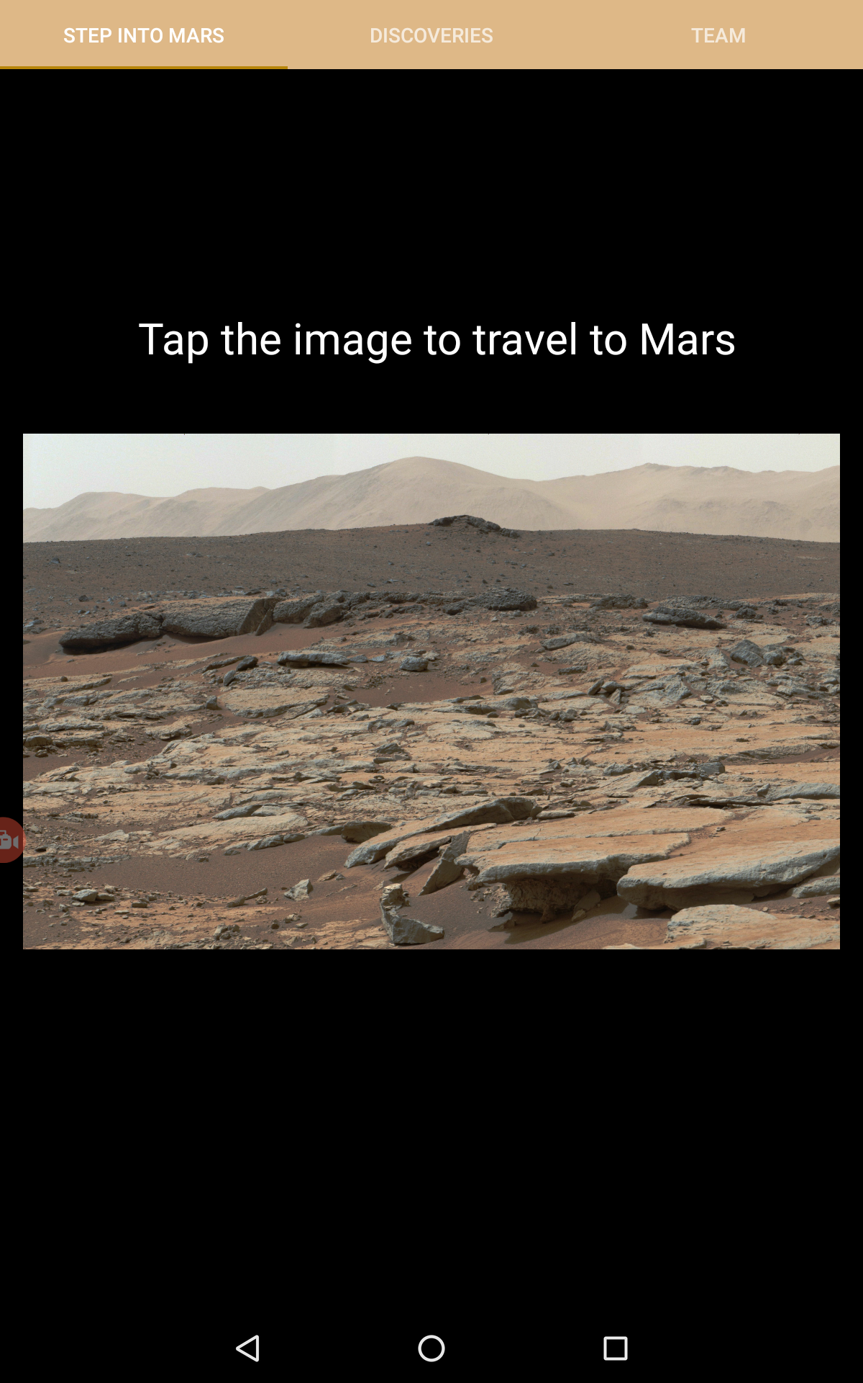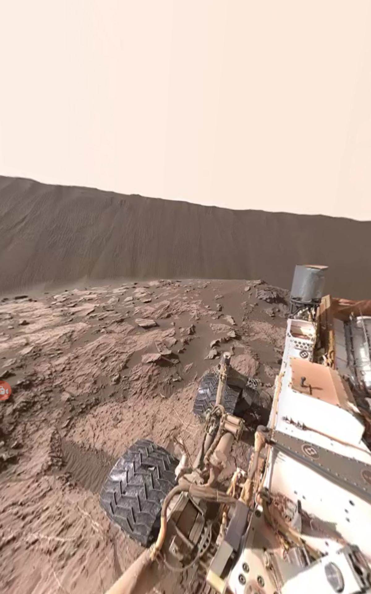

**Mars Rover Virtual Reality:** This is under the Mars Rover button. Students will be able to step into mars when they click the image. It is a 360 degree picture and as they move the device, the picture will move in their direction. They are able to look at the dry ground to the cloudy sky of Mars. They are also able to take a glimpse of the actual rover that is at Mars right now.

Discussion

The To Fly application offers various uses to the audience such as interaction with exhibits from around the world, guidance and promotion within the museum, and increased interaction for parents and guardians. Perhaps, the most valuable use of the application is its accessibility from anywhere around the world, essentially encouraging international visitors and its use as a teaching apparatus in schools globally. All parts of the application have the capability of sparking interest into the user, especially the more advanced concepts like virtual reality and mapping. Regarding guidance and promotion, within the To Fly app, there are a number of features that enhance the visitors experience while they are in the museum, such as extra information within the app that is not available at the museum. Furthermore, the application also helps parents and guardians to better interact in the museum while keeping an eye on their children. For instance, as the child frantically moves from plane to plane within the To Fly exhibit, our team noticed that the parent must follow the child foot to foot in an effort to keep track of them. This reduces the time the parent may have to explore for themselves. The To Fly application hence offers supplementary material in a neat, condensed format, to allow both the child and the parent to have an educational experience.

Within the field of science, the To Fly app teaches users that the worlds of science and technology are not so different. The To Fly application will enhance the visitor experience by integrating the emerging world of mobile technology with a museum of science; two areas that go hand in hand. Exposure to their correlation will give users their own background and education in both concepts, encouraging the younger audience specifically to explore the new world of technology.

Our main suggestion for the next year of interns at the Museum of Discovery and Science is to add animated reality to the app. We feel that this is very important especially for our younger users, because it gives them a chance to explore every part of the exhibit as they look for the site of the animated reality. We also suggest to expand on the trivia portion of the app because it currently only includes ten questions.

Conclusion

In total, we have created an android mobile application that explicitly demonstrates the story of aviation throughout history. It is comprised of features like virtual reality, live air traffic control, and esri mapping that serve as great foundations to peak the user’s interest. All the of code and application details are available at Github for free because education for all is our main intention for the “To Fly” app.

References

<https://github.com/MODS16Apps/To-Fly>

<https://fau.mybalsamiq.com/projects/mods16tofly/Project%20Assignment%201>